# Data Viz Idea – Group 3

From the Project Proposal #5, Idea 2:

Short description: Compose your own hit song

Name visualization technique: Tableau set actions

Interaction: Track user-selected words (chosen from displayed branches)

Narrative: Choose the most popular to write your hit

To elaborate: We proposal a visualization which is part insight and part user exploration. The user starts by choosing an arbitrary word from the word cloud/bubble. The selected word is remembered. The selection resets the cloud such that it displays only words which co-occur with the selected word. This cycle continues until the user stops. The remembered words form the elements for a new song lyric.

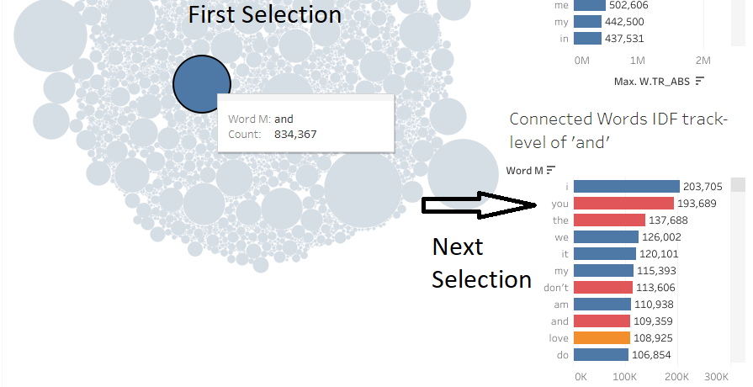

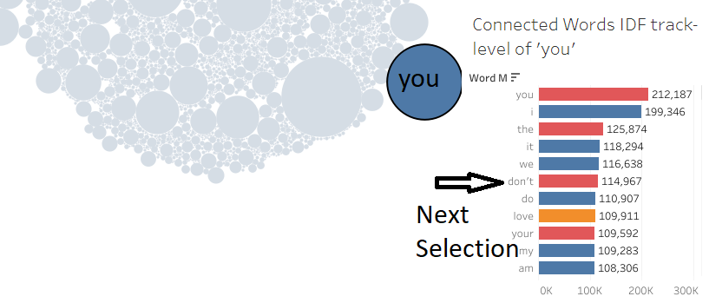

>>> Collected words: ‘and’, ‘you’

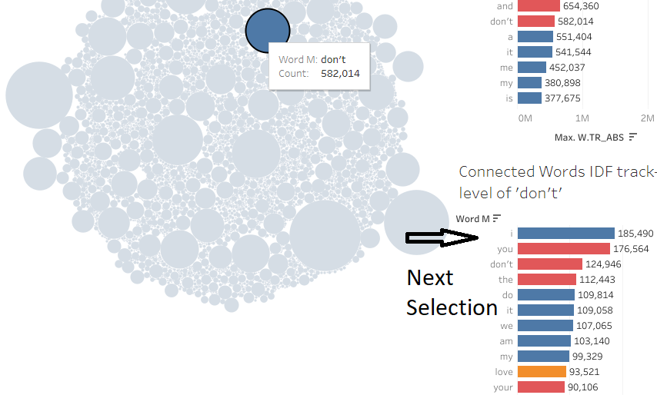

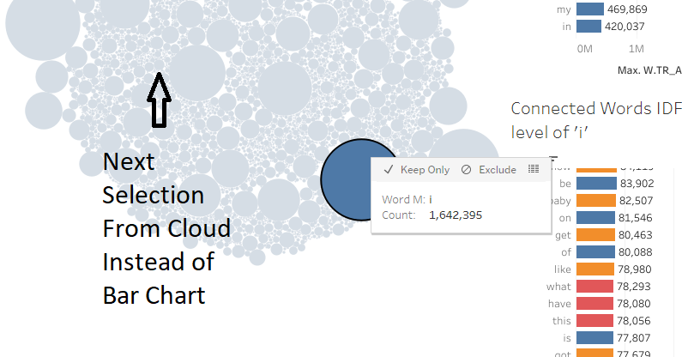

>>> Collected words: ‘and’, ‘you’, ‘don’t’, ‘I’

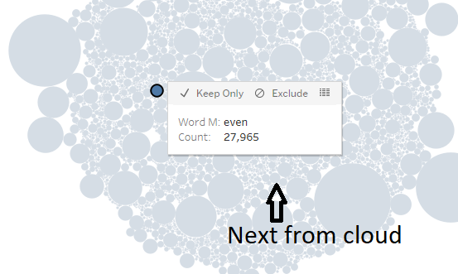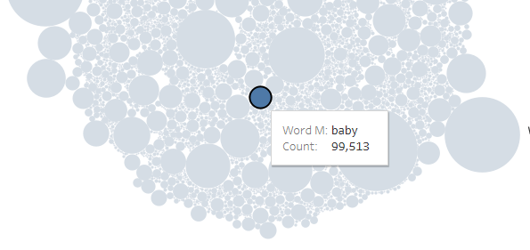

>>> Final collected words: ‘and’, ‘you’, ‘don’t’, ‘I’, ‘even’, ‘baby’

TEAM: This is where I run into trouble.

1. It takes at least 5, sometimes 10 tries to get a collection of words that even vaguely makes sense.
2. The smallest bubbles are the most useful for lyric construction but trying to find them is a nightmare.
3. Even with a bag of words, in order to construct a lyric, we would need a grammar. That is a whole different NLP problem.

I think that Tableau Set relationships might be able to help us here (but it wouldn’t solve problem #4). I spent a lot of last night with the tutorials. In essence, set relationships allow us to filter on relationships rather than values. However, I had a lot of trouble replicating the tutorials.

1. Does anyone know how to get a copy of Tableau professional? The tutorial workbooks are only compatible with Pro and so I had to rebuild data sets by hand. It’s not a good use of time.